PARENT–TEACHER MEETING PLANNER
@CREATIVITY THINK (9483175986/7019689991)

ABSTRACT:
Parent–Teacher Meeting Planner is a web-based scheduling and coordination system designed to simplify and digitize the process of booking Parent–Teacher Meeting (PTM) slots. The platform enables parents to log in, view class-wise availability, book meeting slots, receive reminders, and submit feedback after sessions. Administrators and teachers can configure PTM dates, set availability, manage bookings through a centralized calendar, track attendance, and export schedules or feedback statistics. Developed using Django REST Framework for backend APIs and React with react-calendar for the frontend, the system ensures smooth coordination and time-efficient scheduling for educational institutions..

INTRODUCTION OF THE PROJECT:
Traditional Parent–Teacher Meeting scheduling often involves manual registration, long waiting periods, and the risk of overlapping appointments. Schools struggle to manage class-wise schedules, while parents face inconvenience and lack of clarity regarding slot availability.
The Parent–Teacher Meeting Planner addresses these challenges by digitizing the entire process. Through a clear UI and automated scheduling workflow, parents can book preferred slots, while teachers and admins maintain organized calendars. Reminder notifications, structured feedback collection, and analytics further improve communication and event effectiveness..

PROJECT OBJECTIVES:

• Enable parents to book PTM slots online without queues
• Provide teachers with a calendar interface to set availability
• Allow admins to configure PTM dates, class-wise rules, and global settings
• Offer real-time visibility of available and booked slots
• Send reminders and notifications to reduce absenteeism
• Collect structured feedback after meetings
• Provide analytics on attendance, feedback patterns, and class-wise data
• Support exporting schedules and feedback for documentation

PROBLEM OF THE STATEMENT:
Parent–Teacher Meetings in many institutions lack an organized system, leading to scheduling overlaps, long waiting times, and administrative burden. Schools often struggle to maintain accurate attendance records and parent feedback. The Parent–Teacher Meeting Planner streamlines the process by offering an efficient, digital solution for booking, managing, and analyzing PTM sessions..

MOTIVATION OF THE PROJECT:
• To reduce manual workload for school staff
• To eliminate long queues and unpredictable waiting times for parents
• To improve communication between parents and teachers
• To enhance transparency in PTM slot scheduling
• To use data-driven insights to improve meeting quality
• To digitize traditional PTM processes for modern educational institutions
• To simplify coordination among parents, teachers, and administrators

BLOCK DAIGRAM OF PROJECT:

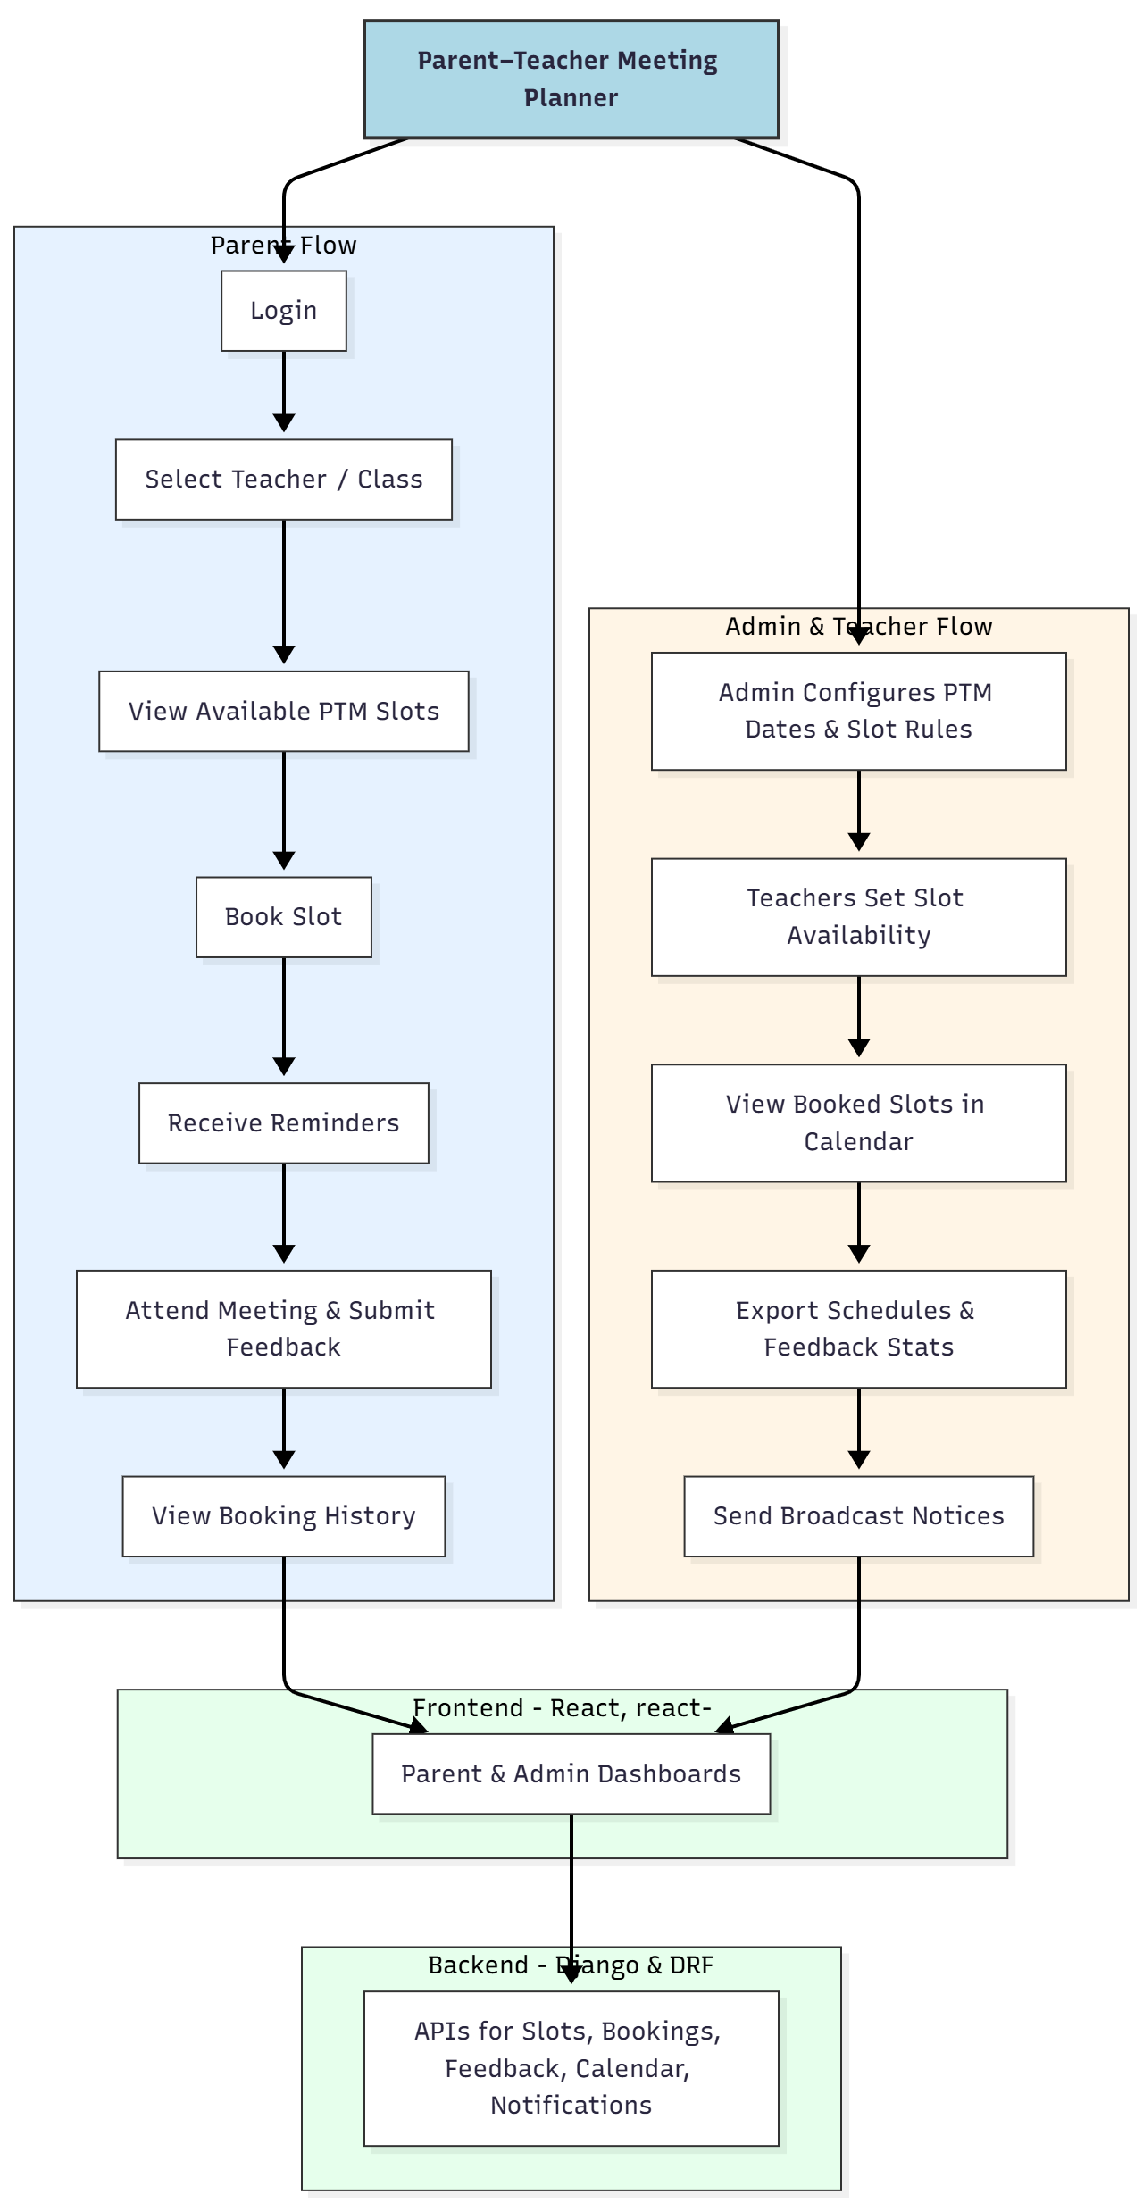

WORKING OF THE PROJECT:
Parents access the web application and log in to view upcoming PTM schedules. They choose the teacher or class, view available time slots, and book a preferred slot. The system sends confirmation along with automated reminders to ensure attendance. After the meeting, parents can submit structured feedback.
Admins configure meeting days, slot durations, and class-wise rules. Teachers set their availability, which is displayed on the parent dashboard. Both admin and teachers can view bookings through an interactive calendar, export schedules, monitor attendance, and analyze feedback patterns for institutional improvement..

SOFTWARE REQUIREMENT:
- Backend:
  - Python 3.x
  - Django
  - Django REST Framework
  - SQLite/PostgreSQL
- Frontend:
  - Node.js and npm
  - React.js
  - Axios
- Development Tools:
  - Visual Studio Code
  - Postman (for testing APIs)
  - Git/GitHub (for version control)
- Server/Deployment (Optional):
  - Gunicorn, Nginx, or Heroku/AWS for hosting

ADVANTAGES OF THE PROJECT:

• Reduces PTM scheduling confusion and overlapping appointments
• Provides a smooth booking experience for parents
• Centralized calendar for teachers and admins
• Automated reminders reduce no-shows
• Class-wise and teacher-wise availability management
• Feedback analysis improves PTM quality
• Exportable reports for documentation
• Increases overall efficiency and transparency

APPLICATIONS OF THE PROJECT:
• Schools (Primary & Secondary)
• Colleges & Intermediate Institutions
• Coaching Institutes
• Training Centers
• Parent–Teacher Associations
• Campus-based educational systems

REFERENCES:

- Django REST Framework Documentation — Django Software Foundation. Django Documentation. Available: https://docs.djangoproject.com/
- Django REST Framework. DRF Documentation. Available: https://www.django-rest-framework.org/
- React. React Official Documentation. Available: https://reactjs.org/docs/getting-started.html
- Redux. Redux Documentation. Available: https://redux.js.org/introduction/getting-started
- PostgreSQL Global Development Group. PostgreSQL Documentation. Available: https://www.postgresql.org/docs/
- MySQL. MySQL Reference Manual. Available: https://dev.mysql.com/doc/
- Git. Git Documentation. Available: https://git-scm.com/doc
- Node.js. Node.js Documentation. Available: https://nodejs.org/en/docs/
- Axios. Axios Documentation. Available: https://axios-http.com/docs/intro
- Socket.io Documentation – https://socket.io/docs/

